VERDURA® RETAINING WALL LANDSCAPING CONSIDERATIONS

Verdura® Wall Introduction
- Fully plantable wall due to typical spacing of blocks within a course (typical 5.5” X 9” for V40)
- Design of lip prevents erosion by holding soil within angle of repose (natural slope of soil)
- Back of the block is open to the backfill soils to allow for root penetration into the embankment soils behind the block face
Considerations for Planting Verdura® Walls
- Site Specific General Considerations
- Geographic location of proposed wall
- Backfill that will be used to build the wall
  - Import or native soil
  - General understanding of where / how deep the soil is being mined from
  - Perform tests on soil
    - Silt / clay content - retains water
    - PH
    - Alkalinity
- What types of plants are native / allowed to the region?
- What look are you after?
- How much water is allowed for irrigation to be sustained over time?
  - Average rainfall vs. what plants need
- Temperature range of site and if plants can survive there

- Plant Selection
- The right plant selection in and around a Verdura® wall can change the entire feel of a project
- Consider blooming color in different seasons of the year – more than one plant type within a wall
- Avoid large trunk plants
- Planting within the wall has the best results for creating texture vs. pure vines
- Consider lifetime of wall (75 years) and creating a long term sustainable plant pallet
- Immediate coverage is sometimes desired but could result in increased maintenance
- Different plants for exterior walls, interior highly visible walls
  - Goal for exterior facing plants may be to blend in and not be seen
  - Goal for interior visible plants may be to add a lot of color and create and interesting landscape for the immediate community
  - Hydro-seeding exterior walls
- Fuel Mod Considerations
  - What plants are allowed in the fuel mod zone
  - Verdura® as a fire wall
- Orientation of wall (South vs. North facing happy plants)
- Ideas for plants
- Climatic Conditions
  - Coastal
  - Inland
  - Desert
  - High Desert
  - Etc.
- Most Common Plant Types
  - Rosemary
  - Bougainville
  - Creeping Fig
  - Ivy Geranium
- Ornamental Planting
- Hydro-seeding
- Drought tolerant and native plant options

- Custom soil blend for infill of blocks available
- 80/20 blended materials available from A-1, Gail, etc.
- Grow Power and other fertilizers can be added during construction

- Irrigation System Considerations
- Different systems work best in different applications / locations of walls
- Pressure loss shutdown to avoid problems
- Ability to shut down automatically when it rains
- Watering at the right time of the day for max efficiency
- Adjusting water per season
- Considering where the walls are facing
- North vs. South Facing
  - A large Verdura® wall can have a south facing part and wrap around a hill where part of the wall is north facing
  - These parts of the wall will have to be irrigated at different amounts

- Different Irrigation Methods Available
- Conventional spray / rotor irrigation
  - Most common and used for over 25 years
  - Recommended for exterior walls where maintenance is limited and walls are subject to adjacent native habitat
  - Generally durable
  - Spray heads need adjustments through life of wall based on plant establishments
  - Don’t forget to plant and irrigate the top of the wall
  - Some water is wasted with spray irrigation
  - Effective on very tall Verdura® walls where safety / maintenance is a concern

- Drip Irrigation fixed to outside face of wall
  - Considered a more efficient way to irrigate
  - Brown tubing recommended
  - If reclaimed, consider brown with purple strip if allowed
  - Emitters need some adjustments over time but don’t need large adjustments when plants establish like spray irrigation
  - When planting the wall create a level area within the planting void to maximize water penetration
  - One drip line across a course of blocks with the right amount of water can irrigate 2 more courses below with the water running down sides of block
  - Some planting pallets don’t require a plant in every cell
  - Rosemary can provide full coverage with one plant per fifth cell
  - The less cells you plant the more mature the plant should be (sprig vs. 6” pot)

- Drip irrigation within the notch cast in the block
  - Ideal for maximum efficiency
  - Least visual impact before plant establishment
  - Wall will outlast irrigation system (rock is stronger than plastic)
  - Risk of break or failure of irrigation system
  - Sophisticated pressure drop emergency shutdown systems are available
  - Could be difficult to maintain on a large high wall
  - Can abandon system and install spray system after plant establishment

- Long-term Maintenance Guidelines Available at www.soilretention.com
Considerations for Trees Above and Below Verdura® Walls
- General Recommendations and Considerations
- Geogrid reinforcements should not be cut to install trees, unless specific designs/details are coordinated prior to wall construction to accommodate
  - Geogrid materials have an open-graded mesh where roots can grow through
  - Geogrid materials can be located as close as 2 feet from TW elevations
- Trees should be located/sized so that mature canopies do not excessively overhang the wall
- Tree type should be selected so that root growth does not create significant ground bulging toward the wall face or below the footing area. The use of root barriers may be necessary for trees within close proximity of wall facing.
- An arborist/landscape architect should be consulted.

- Planting Trees Above Verdura® Walls
- Level Crest Condition
  - Outside of the Geogrid Zone of the wall
    - No restrictions
  - Within the Geogrid Zone for the wall
    - Smaller size trees are recommended that require shallow excavations that will not remove geogrid reinforcements
    - Larger size trees can be accommodated within the geogrid zone; however, specific/coordinated designs should be completed prior to wall construction
    - Contact Soil Retention for coordination
- Sloping Crest Condition
  - Outside of the Geogrid Zone of the wall
    - No restrictions
  - Within the Geogrid Zone for the wall
    - Trees should be planted in the slope area above the TW so that excavations do not remove geogrid reinforcements
    - Generally, trees are suggested to be located approximately 3 to 5 feet higher than the TW elevation to avoid conflict with geogrid reinforcements

- Planting Trees Below Verdura® Walls
- No major restrictions
- Tree excavations should not undermine or disturb the foundation zone of the Verdura® Wall
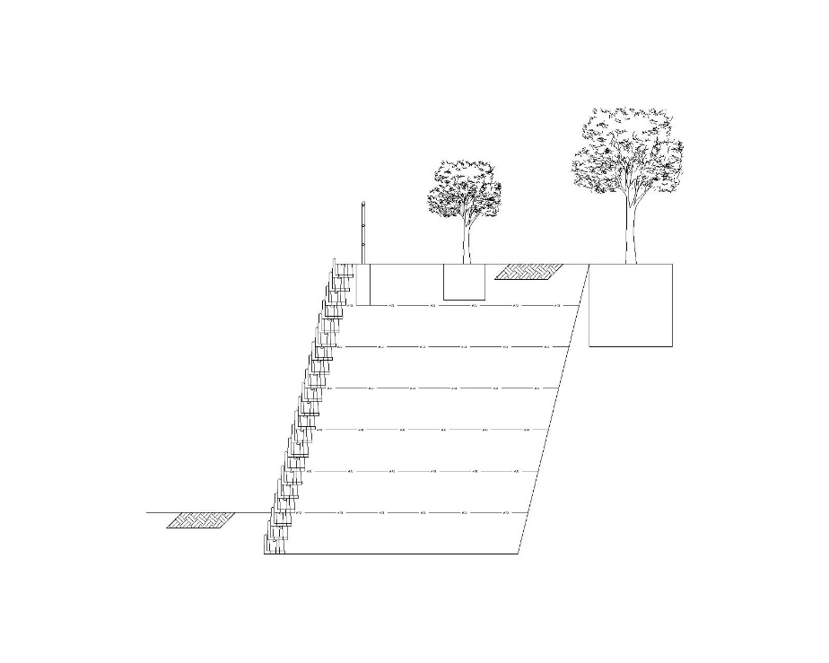
Typical Tree Position for Level Crest Condition Above Verdura® Walls

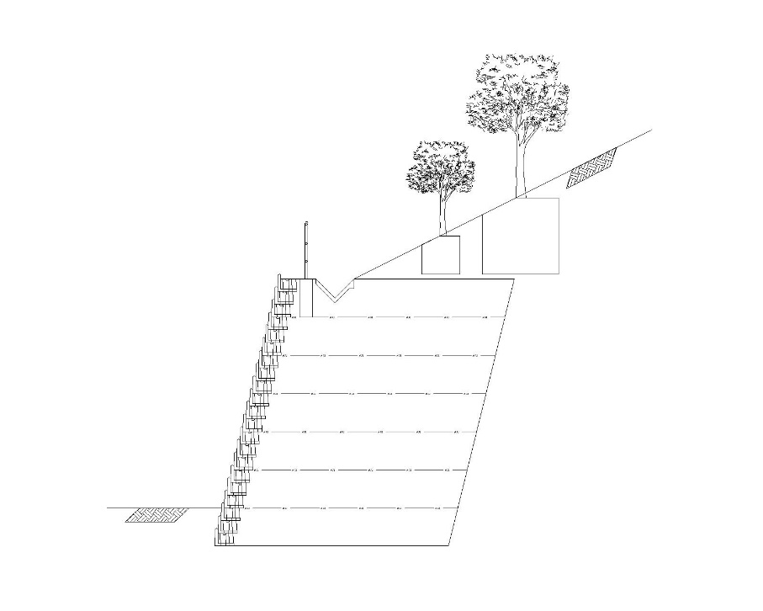
Typical Tree Position for Sloping Crest Condition Above Verdura® Wall

