GUIDELINE FOR DRIVABLE TURF® INSTALLATION

Please read prior to installation and have proper equipment and safety precautions in place.

For additional information please visit our website at www.soilretention.com or call 800-346-7995.

Installer Qualifications: An experienced installer, preferably certified by the Interlocking Concrete Pavement Institute (ICPI), and who has successfully completed installations of pavers or other pavement systems on projects of similar or larger scope and magnitude is recommended.

Planning: Final surface elevations and tolerances should be as specified on the project plans. Special consideration should be given to layout, slope, drainage, root barriers and edging/confinement.

- Drivable Grass® Material Specification

- Permeable, Flexible, Plantable Pavement System: Drivable Grass®
- Nominal Dimensions in inches (l x w x h) : 24 in. x 24 in. x 1.5 in.
- Gross Area: 4 SF
- Weight: 45 lbs.
- Drivable Grass® mats per pallet (each): 60
- Area Covered per Pallet: 240 SF
- Color: Buff/Tan, Grey
- Flexibility (minimum radius of curvature in inches): 12

- Drivable Turf® Material Specification

- Pre-cut Artificial Turf: Drivable Turf®
- Nominal Dimensions in inches (l x w): 4 ft. x 4 ft.
- Gross Area: 16 SF
- Drivable Turf® pieces per box (each): 20
- Area Covered per Box: 320 SF
- Color: Green w/ Brown Thatch

- Main Steps of the Installation

A. Subgrade Preparation/Subsurface Drainage (if required)
B. Perimeter Confinement
C. Geotextile Installation (if required)
D. Base Material Installation
E. Compaction
F. Bedding Installation
G. Screeding
H. Drivable Grass® Mat Placement
I. Spike Installation
J. Sand Infill for Joints
K. Drivable Turf® Installation
L. Sand Infill

- Subgrade Preparation/Subsurface Drainage (if required)

Excavate the installation area to the proper depth to allow for the structural pavement section below the Drivable Turf® installation in accordance with project plans and specifications. Complete any additional over-excavation and re-compaction as required to provide a firm and unyielding subgrade.

Where permeability of the subgrade is important, and site conditions permit excavation into strong native soils, compaction of the subgrade may be minimized to trimming.

Test and approve the subgrade condition and provide written certification confirming the preparation, density and elevations conform to the project plans and specifications. Special consideration should be given for the following conditions:

- Over-excavation depths and re-compaction of subgrade
- Application of filter fabric over prepared subgrade (if required)
- Sub-surface drainage due to low permeable subgrade (if required)

- Perimeter Confinement

Keeping the edges of the Drivable Grass® installation contained is crucial for a successful long-term installation.
- Typically all driving applications require a concrete mow-strip at edge conditions that are being driven over.
- Other edging such as steel edging can be used in other areas where the edge is not driven over.

- Geotextile Installation (if required)

Geotextile type should be in accordance with project plans and specifications. At a minimum, the geotextile should be placed at the bottom and sides of the sub-grade and secured in place to prevent wrinkling. Overlap at the seams of the geotextile should be a minimum of 12 inches.
NOTE: Geotextile is always required for clay soils.

- Base Material Installation

Backfill, level, and compact the required base material to the density, depth/thickness and surface elevation in accordance with the project plans and specifications.

NOTE: A proper aggregate base will contain a gradation of particles that will pack tightly together.

Local, state or provincial standards for aggregate base materials for roads should be used for the gradation and quality of dense-graded aggregate base materials. If no standards exist, follow ASTM D 2940, Standard Specification for Graded Aggregate Material for Bases or Subbases for Highways or Airports. The gradation for base material from this standard is given in the table below. This material should be compacted to a minimum of 95% Standard Proctor density per ASTM D 698 or local standards.

ASTM D 2940: Gradation for Dense-Graded, Crushed Stone Base
Sieve Size | Percent Passing
2 in. (50 mm) | 100
1 1/2 in. (37.5 mm) | 95 to 100
3/4 in. (19.0 mm) | 70 to 92
3/8 in. (19.0 mm) | 50 to 70
No. 4 (4.75 mm) | 35 to 55
No. 30 (0.600 mm) | 12 to 25
No. 200 (0.075 mm) | 0 to 8

NOTE: Consult with Soil Retention and a local aggregate material supplier where a permeability rate and/or water storage is required. In general, a permeable base material that allows compaction is required for the initial 8 inches. This material generally has no more than 3 % fines passing the No. 200 sieve. In CA an example of this material is Caltrans Class 2 Permeable.
Below the initial 8” permeable base, a choker course or filter fabric can be used on top of an open graded rock for additional water storage.

- Compaction Process

To achieve good compaction, use the type of machine that provides the proper force, amplitude, and frequency. Continue to add and compact base material until the top of the base is approximately 2 in. below the final height of the finished elevation. The remaining space is for the 0.5 in. of sand bedding and the 1.5 in.-thick Drivable Grass® mats.

Establish final height by setting string lines to final elevation. The elevation between the material base and the final elevation should be uniform.

Note: The recommended base surface tolerance should be (+/-) 3/8 in. over a 10 ft. straight edge.

- Bedding Installation

A minimum uniform bedding thickness of 0.5 in. should be used for non-planted installations.

Bedding should consist of clean, non-plastic, sand that is free from deleterious or foreign matter. The sand shall be sharp and manufactured from crushed rock. Do not use limestone screenings or stone dust. The particles shall conform to the grading requirements given in the table below:

ASTM C33 CSA A23.1-M94
Sieve Size | Percent Passing
3/8 in. (9.5 mm) | 100
No. 4 (4.75 mm) | 95 to 100
No. 8 (2.36 mm) | 85 to 100
No. 16 (1.18 mm) | 50 to 85
No. 30 (0.600 mm) | 25 to 60
No. 50 (0.300mm) | 0 to 30
No. 100 (0.15mm) | 2 to 10
NOTE: It is important to moisten, but do not saturate sand bedding prior to installation.
- Screeding

Spread moist sand uniformly and screed. Use screed rails/edge restraints and string lines to assure the screeded sand will allow the top of the and Drivable Grass® mats to conform to designed finished elevations. Allow 1/8 in. to 1/4 in. above specified surface elevations to compensate for minor settlement.

- Drivable Grass® Mat Placement

Partial mats will be necessary. Fit the area first to avoid ending up with small pieces of the individual muffins or mats that would likely come lose. Do not drag the Drivable Grass® mats or walk on sand bedding as this can cause uneven placement.

Install the Drivable Grass® mats in a running bond pattern. Working in one axial direction at a time, securely butt mats up against each other. Trying to install Drivable Grass® in more than one axis at a time could result in a significant alignment problem. Make sure to check the alignment in both directions. Make minor adjustments to Drivable Grass® mats as required to maintain good grid pattern alignment.

The grid inside the Drivable Grass® mats can be cut with a utility knife or chisel to fit site conditions. At terminating edges or curved installations, the mats can also be cut with a masonry blade. Be sure to properly clean the Drivable Grass® mats after cutting with a dry blade by brushing or blowing to avoid staining from fine dust.

Partial mats (minimum of 2 X 2 muffins) should be limited to edges where driving is limited. Make sure to make minor adjustments to fit large pieces leaving no significant gaps between the edge restraint and the mats. Secure partial mats using 8 in. spikes in at least two locations.

- Seat the Drivable Grass® mats into the bedding course using a low-amplitude, 75-90 Hz vibrating plate compactor capable of at least 4,000 lbs. centrifugal compaction force. Use a fabric or pad between the compactor and Drivable Grass® mats to prevent scuffing or chipping.

- Final surface tolerances should be as follows:

  - Final surface tolerance of Drivable Grass® mats shall not deviate more than (+/-) 3/8 in. over a 10-foot straight edge.
  - Surface elevation of the Drivable Grass® mats shall be 1/8 in. to 1/4 in. above adjacent drainage inlets, concrete collars or other type of inlets.
  - Lippage: No greater than 1/8 in. difference in height between Drivable Grass® mats.

- Spike Installation (recommended for vehicular driving installations)

Required Tools:

- Air Compressor: 5 CFM at 90 psi (min)
- Air Hose Size: 3/8 in. diameter (min)
- Soil Retention Installation Kit (see Photo 1)
- Soil Retention Hammer Rod
- Soil Retention Nail Guide
- Air Hammer: 3 CFM at 90 PSI, Stroke length 1.5 in.
- Oil (for Air Hammer)

Note: Frequently check the oil level of the air hammer. Refill oil level as necessary with the oil provided. Operating the air hammer without oil will result in significant damage.
- 8 in. Galvanized Spikes: 2 per mat (spiral spikes recommended for hard / large aggregate penetrations)

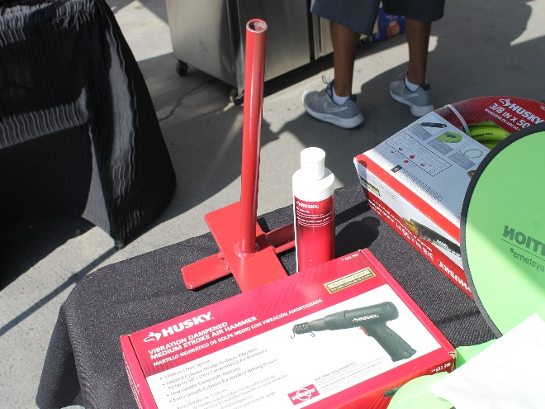
Photo 1: Soil Retention Installation Kit Photo 2: Spike location

Spike Installation Sequence:

  - Place the 8 in. galvanized spikes in two locations (see Photo 2).
  - Using a hammer, set the 8 in. galvanized spikes in place prior to using the air hammer.
  - Place the nail guide over the 8 in. galvanized spike.
  - Using the hammer rod and air hammer, drive the 8 in. spikes to the base of the Drivable Grass® mat (see Photo 3). Do not keep driving the spikes after the end of the hammer rod has reached the base of the nail guide as this may cause damage to the Drivable Grass® mats.

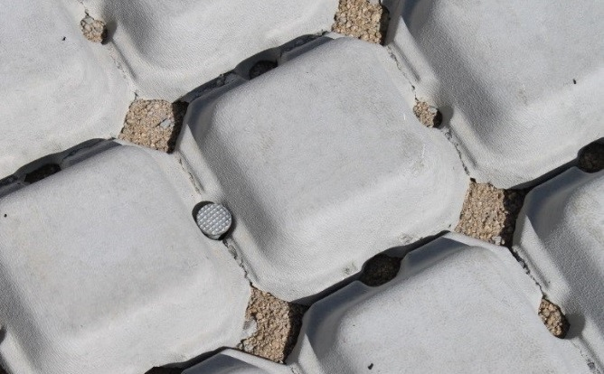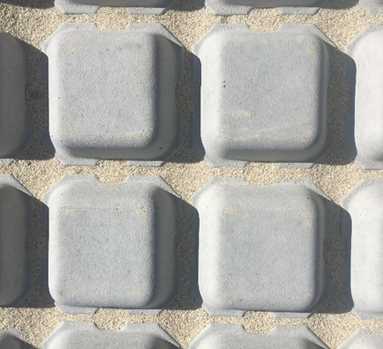
Photo 3: Spike driven into base of mat. Photo 4: Sand filled to base of Drivable Grass mat

- Sand Infill for Joints

Required Items and Tools:
- Sand (#30 industrial sand)
- Drop Spreader
- Blower

Use a drop spreader and blower, to fill sand to the top of the Drivable Grass® mat base (see Photo 4).
- Drivable Turf® Installation

Required Items and Tools:
- Polyurethane Adhesive, i.e.
- 28 oz. SRW Products – Rapid-Set Polyurethane (slower cure times)
- 28 oz. Gator Block Bond - XP Xtra Performance Adhesive, or
- Caulking Gun (electric and / or drip free recommended)
- Push Broom
- Blower
- Utility Knife
- Caulking Trowel
- Power Brush
- ½ inch heavy sled brick jointer (recommended: OX-P030312)

Drivable Turf® Installation Preparation

  - Clean area of any debris with blower prior to Drivable Turf® placement.
  - Pre-fit the Drivable Turf® over the Drivable Grass® mats. Lay flat in sunlight to get any memory out of the plastic. Pay special attention to the orientation of the Drivable Turf® to assure the grass blades and designed edge pattern go in the same direction (see Photo 5).
  - Make necessary clean cuts with a utility knife to fit the area. Edge terminations may require the Drivable Turf® to be cut to avoid bulging (see Photo 6).

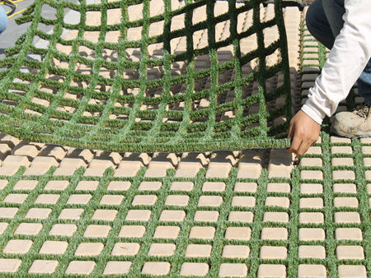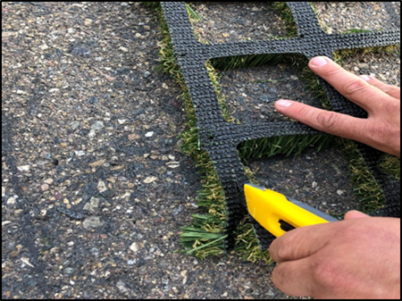
Photo 5: Pre-Fit Installation of Drivable Turf. Photo 6: Backing cut for an edge termination

  - Clean area from any debris or loose fibers before application of adhesive.

Adhesive Application

Be sure to read the adhesive instructions paying close attention to the working time, cure time and temperature. A test application prior to the turf installation is recommended.

- Apply ¼ in. Dia. Polyurethane Adhesive along the base of the Drivable Grass® mat (see Photo 7). Use 1 oz/sq ft for planning purposes.
- Using a ¾ in. caulking trowel, spread the polyurethane adhesive between the Drivable Grass® mat pads to increase the contact area of the Drivable Turf® assuring a proper bond. This step can be skipped with proper use of the heavy sled brick jointer.

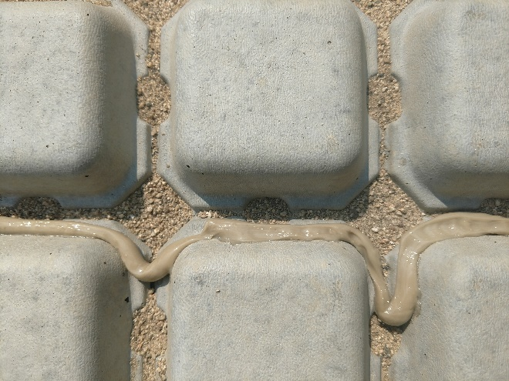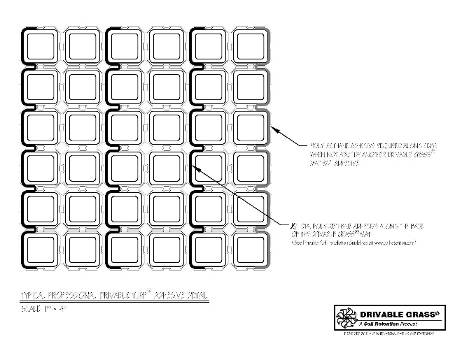
Photo 7: Adhesive Application Photo 8: Typical Professional Drivable Turf® Adhesive Detail

- Lay the Drivable Turf® over the Drivable Grass® mats and firmly press into position using a ½ inch heavy sled brick jointer (recommended: OX-P030312)
- (see Photo 9)
- Pressing the Drivable Turf® into position is a two-step process. This should be done immediately after placement and once again when the polyurethane adhesive is tacky to the touch and turf stays in place. This step should be coordinated with test application.
- Let adhesive cure before next step (24h usual cure time).

Note: Applying too much adhesive and not pressing it down will elevate the turf too high and will damage the turf with vehicular driving. Adhesive should be pressed down to about 1/16”.

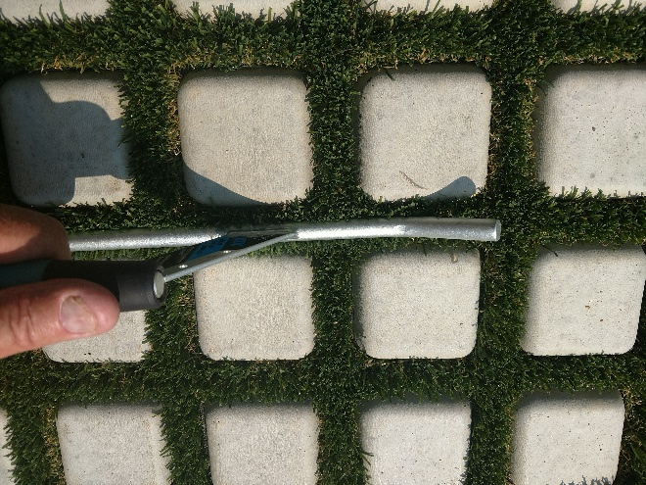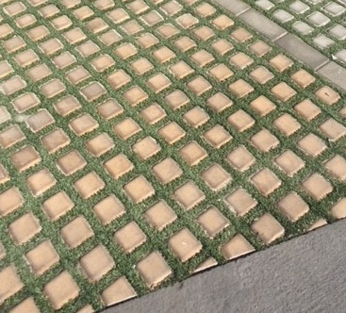
Photo 9: Pressing Drivable Turf® firmly into position Photo 10: Sand broomed into Drivable Turf®
with a heavy sled brick jointer

- Sand Infill

- Apply #30 industrial sand using a drop spreader. Colored sand or other common turf infills can be used to match a landscape ground cover (see Photo 10).
- Broom-in sand to 1/4 in. or less below the Drivable Grass® mat surface as desired for look and feel of the finished installation. 1 cubic foot of sand will cover approximately 40 square feet of area. This step should be coordinated w/ test application
- Use a power brush, in both directions, to stand up the blades and to create a finished walkable surface (optional).
- Water down the area with a hose to settle the sand and collect and loose debris.

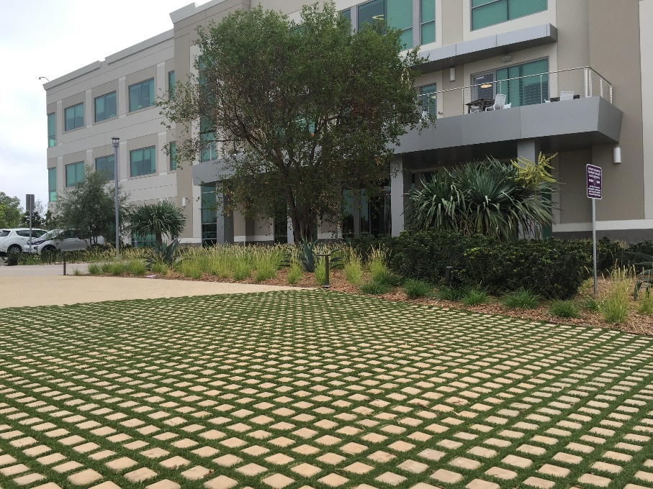
Photo 11: Finished Drivable Turf® installation.

