**DRIVABLE GRASS® GUIDELINE FOR PLANTED INFILL INSTALLATION**

Please read through this instruction completely before beginning your installation. Be sure the proper equipment, and safety precautions are in place.

Installer Qualifications: An experienced installer, preferably certified by the Interlocking Concrete Pavement Institute (ICPI), who has successfully completed installations of pavers or other pavement systems on projects of similar or larger scope and magnitude.

1. **Main Components of the Installation**

* Subgrade Preparation
* Base Material Installation
* Compaction
* Sand Bedding Installation
* Screeding
* Mat Placement
* Infill Installation

1. **Drivable Grass® Material Specification**

* Permeable, Flexible, Plantable Pavement System: Drivable Grass®
* Nominal Dimensions in inches (l x w x h) : 24 x 24 x 1.5
* Gross Area of Each Mat in square feet: 4
* Weight of Each Mat in pounds: 45
* Infill Area in percent: 60
* Mats per pallet (each): 60
* Area Covered per Pallet in square feet: 240
* Color: Buff/tan, Grey
* Flexibility (minimum radius of curvature in inches): 12
* Concrete Compressive Strength @ 28 days in psi: 5,000
* Propriety Grid Reinforcement: Engineered Plastic

1. **Base and Bedding Installation Guideline**
2. Subgrade Preparation:

Excavate the area to the proper depth for intended use. Complete all over-excavation and re-compaction as required.

Where permeability of the subgrade is important, excavation is in native strong soils, and site conditions permit, compaction of the subgrade may be limited to trimming.

The table below is provided as a general guideline to determine base material thickness given a variety of soil conditions.

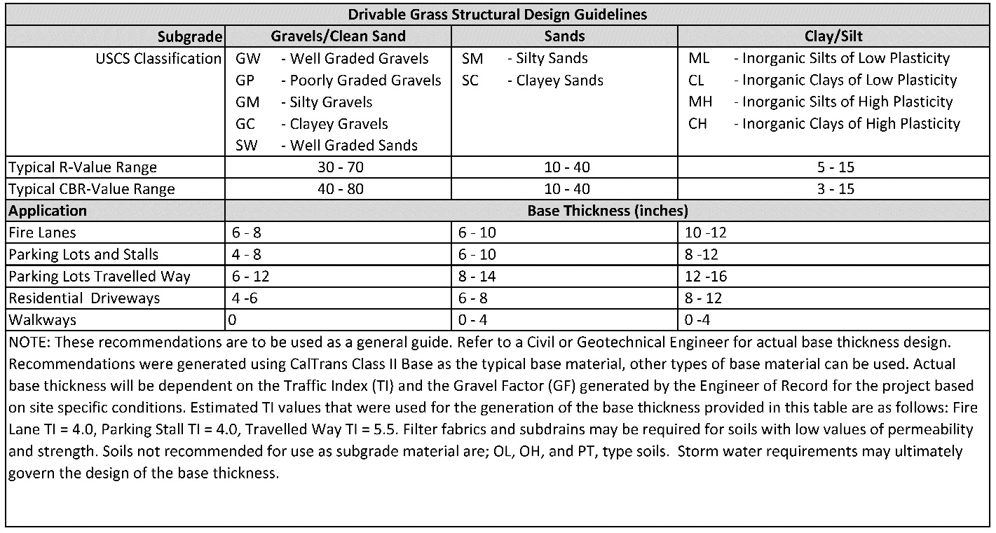

**NOTE: A qualified engineer should test and approve the subgrade for the following design considerations prior to the placement of base materials:**

* **Over-excavation and re-compaction of subgrade**
* **Filter fabric over prepared subgrade (if required)**

1. Aggregate Base Material Installation**:**

Proper aggregate base material and installation is critical to a successful installation. If the base and sub-grade is not properly compacted, the Drivable Grass® mats will settle over time, and rutting/deformation may occur. Three factors affect compaction; 1) type of aggregate base, 2) moisture content of the aggregate base and 3) type of compacting effort required (pressing, ramming, or vibration). It is important to soak, but do not saturate, each layer of base material before compaction.

***NOTE: A proper aggregate base, will contain a gradation of particles that will pack tightly together.***

Local, state or provincial standards for aggregate base materials for roads should be used for the gradation and quality of dense-graded aggregate base materials. If no standards exist, follow ASTM D 2940, Standard Specification for Graded Aggregate Material for Bases or Subbases for Highways or Airports. The gradation for base material from this standard is given in the table below. This material should be compacted to a minimum of 95% standard Proctor density per ASTM D 698.

|  |  |
| --- | --- |
| ASTM D 2940  Gradation for Dense-Graded, Crushed Stone Base | |
| Sieve Size | Percent Passing |
| 2 in. (50 mm) | 100 |
| 1 1/2 in. (37.5 mm) | 95 to 100 |
| 3/4 in. (19.0 mm) | 70 to 92 |
| 3/8 in. (19.0 mm) | 50 to 70 |
| No. 4 (4.75 mm) | 35 to 55 |
| No. 30 (0.600 mm) | 12 to 25 |
| No. 200 (0.075 mm) | 0 to 8 |

**NOTE: Caltrans Class II Base is recommended for California installations.**

1. Compaction Process**:**

To achieve good compaction, use the type of machine that provides the proper force, amplitude, and frequency. Use plate compactors that run between 75 to 90 hertz amplitude and apply a 4,000 to 5,000 lb. centrifugal force. Typical compaction equipment is shown below**:**



Plate Compactor Roller Compactor Plate Rammer

***Note: Use a 4000-5000 lb. plate compactor for walks and patios. For driveways, parking lots, fire lanes and other large areas a vibratory roller or plate rammer is recommended.***

Install the base material in layers to ensure adequate compaction. For walks and patios, using a hand tamper, spread an even layer of base material about 2" thick. If using a plate compactor, spread an even base material in 3" to 4" layers.

For driveways, parking lots, fire lanes and other large areas using a plate rammer or vibratory roller, spread an even base material in 6" to 8" layers.

Wet, but do not saturate, the base material as you compact. Compact each layer of base material until it cannot be compacted any further then add additional layers and compact.

Continue to add and compact base material until the top of the base is approximately 3.5" below the final height of the finished elevation. The remaining space is for the 2.0" of 75% sand and 25% fine ground compost mix and the 1.5”-thick Drivable Grass® mats.

***Note: Establish final height by setting string lines to final elevation.*** ***The elevation between the material base and the final elevation should be uniform.***

***Note: Special attention should be given to slope away from buildings.***

1. Sand Bedding Installation**:**

For planted applications, a minimum uniform thickness of 2” consisting of a thorough mix of 75% sand and 25% fine ground compost shall be used.

Sand shall be clean, non-plastic, and free from deleterious or foreign matter. The sand shall be sharp and manufactured from crushed rock. Do not use limestone screenings or stone dust. The particles shall conform to the grading requirements given in the table below:

|  |  |
| --- | --- |
| ASTM C33 CSA A23.1-M94 | |
| Sieve Size | Percent Passing |
| 3/8 in. (9.5 mm) | 100 |
| No. 4 (4.75 mm) | 95 to 100 |
| No. 8 (2.36 mm) | 85 to 100 |
| No. 16 (1.18 mm) | 50 to 85 |
| No. 30 (0.600 mm) | 25 to 60 |
| No. 50 (0.300mm) | 0 to 30 |
| No. 100 (0.15mm) | 2 to 10 |

The Compost material should be finely ground, well screened composted products such as composted manures, mushroom compost or green-waste compost. Material should be able to mix well with sand, able to hold moisture, and provide nutrient

***NOTE: It is important to moisten, but do not saturate sand prior to installation.***

1. Screeding:

Use two 2" diameter PVC or steel pipes on the compacted base material spaced 6'- 8' apart and parallel to each other. Set string lines to the desired elevations of the finished pavement and check the height of the screed bars to be sure that the screeded sand and Drivable Grass® mats conform to finished elevations when compacted. Hold the pipes in place by placing sand around them. Fill the area between the pipes with sand. Level the sand by trawling a screed board along the top of the pipes.

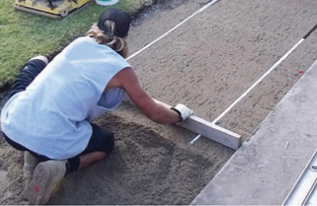

Check final elevations for conformance to the drawings. Allow 1/8” to 1/4” above specified surface elevations to compensate for minor settlement.



**Figure 1: Typical Drivable Grass® Detail**

1. **Drivable Grass® Mat Installation**

General Notes:

* When moving the Drivable Grass® mats by hand, use proper lifting techniques to protect the back, and avoid pinching fingers while placing the Drivable Grass® mats.
* Do not drag the Drivable Grass® mats on bedding material as this can cause uneven placement.

Procedure:

1. Install Drivable Grass® mats in a running bond pattern. Place the mats to the line, grades and locations required by the contract drawings. Working in one axial direction at a time, securely butt mats up against each other and leave no significant gaps. ***Trying to install Drivable Grass® in more than one axis at a time could result in a significant alignment problem***. Make sure to check the alignment in both directions. Adjust Drivable Grass® mats as required to maintain good grid pattern alignment.

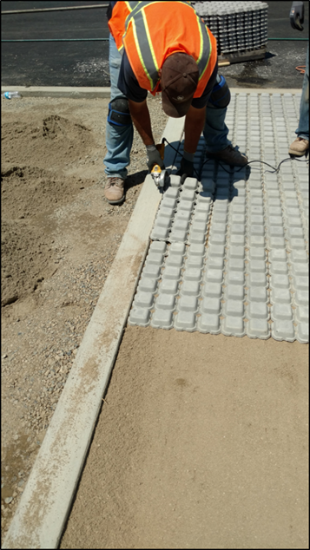

**Figure 2: Mats installed per contract drawings in running bond pattern, in one axial direction**

1. The grid inside the Drivable Grass® mats can be cut with a utility knife or chisel to fit site conditions. At terminating edges or curved installations, the mats can also be cut with a masonry blade. Be sure to properly clean the Drivable Grass® mats after cutting with a dry blade by brushing or blowing to avoid staining from fine dust. Where possible, partial mats should be limited to edges where driving is limited. Also, no significant gaps should be left between the edge restraint and the mats.
2. Seat the Drivable Grass® Mats into the bedding course using a low-amplitude, 75-90 Hz plate compactor capable of at least 4,000 lbs. centrifugal compaction force. Use a fabric or pad between the compactor and Drivable Grass® mats to prevent cracking or chipping.
3. Final surface tolerances should be as follows:
   1. Final surface tolerance of Drivable Grass® mats shall not deviate more than (+/-) 3/8” over a 10-foot straight edge.
   2. Surface elevation of the Drivable Grass® mats shall be 1/8” to 1/4” above adjacent drainage inlets, concrete collars or other type of inlets.
   3. Lippage: No greater than 1/8” difference in height between Drivable Grass® mats.
4. **Irrigation**

Drip Irrigation

Drip irrigation is recommended for small areas such as walks, patio area and parking stalls. Drip irrigation saves water by allowing water to drip slowly directly to the soil around the roots of your plants, through a network of valves, pipes, tubing, and emitters.

The drip tubing should be placed every 8” on-center between Drivable Grass muffins for all types planted infill applications. The flow rate and emitter spacing will depend on the type of grass used as an infill. Consult with the drip irrigation supplier such as NETAFIM® Drip solutions or equivalent for dripline recommendations. ***Tube diameter should range between 12mm and 17mm O.D***.

Conventional Spray Irrigation

Conventional spray irrigation is recommended for large areas such as parks, long driveways and fire access lanes.

The irrigation plumbing will need to buried 4-6” below the surface and laid before the installation Drivable Grass mats. A muffin will need to be cut out of the Drivable Grass Mat to allow the sprinkler to protrude to the surface. This can be done using a utility knife or chisel.

1. **Grass Infill Types**

* Hydroseeding
* Seeding
* Sodding

Hydroseeding:

1. Fill the installed mats with the same soil mix as used for the bedding layer. Use a push broom to spread the soil mix evenly, recessing the mix at least 1/4" below the mat surface. For best results the infill should not be saturated.
2. In a tank, mix together the water, seed, fertilizer, and either the mulch or cellulose fiber. Attach the tank with the seeding solution to a hose and spray the area thoroughly.
3. Wet the lawn often for the first week, keeping the area moist to give the seed and fertilizer a chance to work. Assure the seeds never dry out.
4. Keep foot traffic to a minimum and don’t allow children or pets to walk on the lawn until it is full and lush.
5. Mow your lawn for the first time 1 month after germination.

Installing Seed:

1. Fill the installed mats with the same soil mix as used for the bedding layer. Use a push broom to spread the soil mix evenly, recessing the mix at least 1/4" below the mat surface. For best results the infill should not be saturated.
2. Broadcast grass seed evenly over the Drivable Grass® mats. Contact your local nursery to determine the best seed mixture for your region’s climate and proposed use. Sweep or lightly water excess seeds off the mat and into the soil mix.
3. Lightly cover the seeded soil mix with a topper/seed cover. The top dressing should be made of organic material and kept moist to secure germination.
4. Scatter a thin layer of straw over seeds to hold moisture and prevent runoff.
5. Keep seeds moist as they sprout, watering often so germinating seeds never dry out.
6. Keep foot traffic to a minimum and don’t allow children or pets to walk on the lawn until it is full and lush.
7. Mow your lawn for the first time 1 month after germination.

Laying Sod:

1. When installing sod, completely cover the Drivable Grass® mats approximately 1/4” above surface with the 75% sand and 25% fine ground compost mixture.

**NOTE: Estimated Infill Volume = 0.2 Cubic Feet per Mat OR 0.05 Cubic Feet per Square Foot.**

1. Brush the 75% sand and 25% fine ground compost mixture across all seams using a strong push broom. Take care not to push up loose turf edges.
2. Use a lawn roller to push sod firmly against soil beneath.
3. Limit traffic on the sod for the first 10 days to the allow the roots to establish. This includes children and pets. Keep the soil moist to establish the new grass. Mow the project area for the 1st time when the grass reaches a height of 2 to 3 inches.