**DRIVABLE GRASS® GUIDELINE FOR NON-PLANTED/DRY INFILL INSTALLATION**

**FOR VEHICULAR DRIVING**

Please read through this instruction completely before beginning your installation. Be sure the proper equipment, and safety precautions are in place.

Installer Qualifications: An experienced installer, preferably certified by the Interlocking Concrete Pavement Institute (ICPI), who has successfully completed installations of pavers or other pavement systems on projects of similar or larger scope and magnitude.

1. **Main Components of the Installation**

* Subgrade Preparation
* Base Material Installation
* Compaction
* Sand Bedding Installation
* Screeding
* Mat Placement
* Stake Installation
* Infill Installation

1. **Drivable Grass® Material Specification**

* Permeable, Flexible, Plantable Pavement System: Drivable Grass®
* Nominal Dimensions in inches (l x w x h) : 24 x 24 x 1.5
* Gross Area of Each Mat in square feet: 4
* Weight of Each Mat in pounds: 45
* Infill Area in percent: 60
* Mats per pallet (each): 60
* Area Covered per Pallet in square feet: 240
* Color: Buff/tan, Grey
* Flexibility (minimum radius of curvature in inches): 12
* Concrete Compressive Strength @ 28 days in psi: 5,000
* Propriety Grid Reinforcement: Engineered Plastic

1. **Base and Bedding Installation Guideline**
2. Subgrade Preparation:

Excavate the area to the proper depth for intended use. Complete all over-excavation and re-compaction as required.

Where permeability of the subgrade is important, excavation is in native strong soils, and site conditions permit, compaction of the subgrade may be limited to trimming.

The table below is provided as a general guideline to determine base material thickness given a variety of soil conditions.

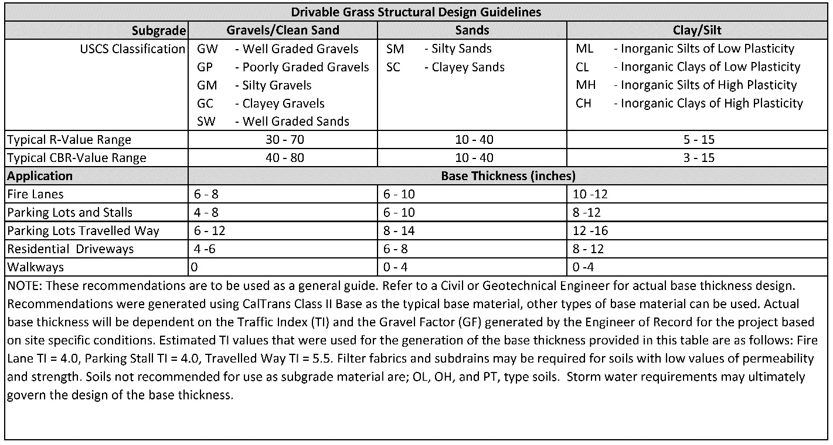

**NOTE: A qualified engineer should test and approve the subgrade for the following design considerations prior to the placement of base materials:**

* **Over-excavation and re-compaction of subgrade**
* **Filter fabric over prepared subgrade (if required)**
* **Sub-drains due to low permeable subgrade (if required)**

1. Aggregate Base Material Installation**:**

Proper aggregate base material and installation is critical to a successful installation. If the base and sub-grade is not properly compacted, the Drivable Grass® mats will settle over time, and rutting/deformation may occur. Three factors affect compaction; 1) type of aggregate base, 2) moisture content of the aggregate base and 3) type of compacting effort required (pressing, ramming, or vibration). It is important to soak, but do not saturate, each layer of base material before compaction.

***NOTE: A proper aggregate base, will contain a gradation of particles that will pack tightly together.***

Local, state or provincial standards for aggregate base materials for roads should be used for the gradation and quality of dense-graded aggregate base materials. If no standards exist, follow ASTM D 2940, Standard Specification for Graded Aggregate Material for Bases or Subbases for Highways or Airports. The gradation for base material from this standard is given in the table below. This material should be compacted to a minimum of 95% standard Proctor density per ASTM D 698.

|  |  |
| --- | --- |
| ASTM D 2940  Gradation for Dense-Graded, Crushed Stone Base | |
| Sieve Size | Percent Passing |
| 2 in. (50 mm) | 100 |
| 1 1/2 in. (37.5 mm) | 95 to 100 |
| 3/4 in. (19.0 mm) | 70 to 92 |
| 3/8 in. (19.0 mm) | 50 to 70 |
| No. 4 (4.75 mm) | 35 to 55 |
| No. 30 (0.600 mm) | 12 to 25 |
| No. 200 (0.075 mm) | 0 to 8 |

**NOTE: Caltrans Class II Base is recommended for California installations.**

1. Compaction Process**:**

To achieve good compaction, use the type of machine that provides the proper force, amplitude, and frequency. Use plate compactors that run between 75 to 90 hertz amplitude and apply a 4,000 to 5,000 lb. centrifugal force. Typical compaction equipment is shown below**:**



Plate Compactor Roller Compactor Plate Rammer

***Note: Use a 4000-5000 lb. plate compactor for walks and patios. For driveways, parking lots, fire lanes and other large areas a vibratory roller or plate rammer is recommended.***

Install the base material in layers to ensure adequate compaction. For walks and patios, using a hand tamper, spread an even layer of base material about 2" thick. If using a plate compactor, spread an even base material in 3" to 4" layers.

For driveways, parking lots, fire lanes and other large areas using a plate rammer or vibratory roller, spread an even base material in 6" to 8" layers.

Wet, but do not saturate, the base material as you compact. Compact each layer of base material until it cannot be compacted any further then add additional layers and compact.

Continue to add and compact base material until the top of the base is approximately 2" below the final height of the finished elevation. The remaining space is for the 0.5" clean sharp sand bed and the 1.5”-thick Drivable Grass® mats.

***Note: Establish final height by setting string lines to final elevation.*** ***The elevation between the material base and the final elevation should be uniform.***

***Note: Special attention should be given to slope away from buildings, and adding crowns in driveways.***

1. Sand Bedding Installation**:**

Sand shall be clean, non-plastic, and free from deleterious or foreign matter. The sand shall be sharp and manufactured from crushed rock. Do not use limestone screenings or stone dust. The particles shall conform to the grading requirements given in the table below:

|  |  |
| --- | --- |
| ASTM C33 CSA A23.1-M94 | |
| Sieve Size | Percent Passing |
| 3/8 in. (9.5 mm) | 100 |
| No. 4 (4.75 mm) | 95 to 100 |
| No. 8 (2.36 mm) | 85 to 100 |
| No. 16 (1.18 mm) | 50 to 85 |
| No. 30 (0.600 mm) | 25 to 60 |
| No. 50 (0.300mm) | 0 to 30 |
| No. 100 (0.15mm) | 2 to 10 |

***NOTE: It is important to moisten, but do not saturate sand prior to installation.***

1. Screeding:

Use two 0.5" diameter PVC or steel pipes on the compacted base material spaced 6'- 8' apart and parallel to each other. Set string lines to the desired elevations of the finished pavement and check the height of the screed bars to be sure that the screeded sand and Drivable Grass® mats conform to finished elevations when compacted. Hold the pipes in place by placing sand around them. Fill the area between the pipes with sand. Level the sand by trawling a screed board along the top of the pipes.

Check final elevations for conformance to the drawings. Allow 1/8” to 1/4” above specified surface elevations to compensate for minor settlement.



**Figure 1: Typical Drivable Grass® Detail**

1. **Drivable Grass® Mat Installation**

General Notes:

* When moving the Drivable Grass® mats by hand, use proper lifting techniques to protect the back, and avoid pinching fingers while placing the Drivable Grass® mats.
* Do not drag the Drivable Grass® mats on bedding material as this can cause uneven placement.

Procedure:

1. Install Drivable Grass® mats in a running bond pattern. Place the mats to the line, grades and locations required by the contract drawings. Working in one axial direction at a time, securely butt mats up against each other and leave no significant gaps. ***Trying to install Drivable Grass® in more than one axis at a time could result in a significant alignment problem***. Make sure to check the alignment in both directions. Adjust Drivable Grass® mats as required to maintain good grid pattern alignment.

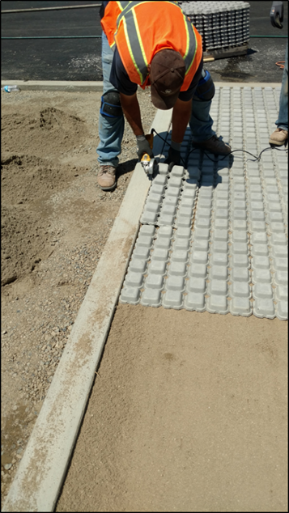

**Figure 2: Mats installed per contract drawings in running bond pattern, in one axial direction**

1. The grid inside the Drivable Grass® mats can be cut with a utility knife or chisel to fit site conditions. At terminating edges or curved installations, the mats can also be cut with a masonry blade. Be sure to properly clean the Drivable Grass® mats after cutting with a dry blade by brushing or blowing to avoid staining from fine dust. Where possible, partial mats should be limited to edges where driving is limited. Also, no significant gaps should be left between the edge restraint and the mats.
2. Seat the Drivable Grass® Mats into the bedding course using a low-amplitude, 75-90 Hz plate compactor capable of at least 4,000 lbs. centrifugal compaction force. Use a fabric or pad between the compactor and Drivable Grass® mats to prevent cracking or chipping.
3. Final surface tolerances should be as follows:
   1. Final surface tolerance of Drivable Grass® mats shall not deviate more than (+/-) 3/8” over a 10-foot straight edge.
   2. Surface elevation of the Drivable Grass® mats shall be 1/8” to 1/4” above adjacent drainage inlets, concrete collars or other type of inlets.
   3. Lippage: No greater than 1/8” difference in height between Drivable Grass® mats.
4. **Stake Installation**

***Note: Stakes are recommended for vehicular driving installations.***

Required Tools:

* Air Compressor: 5 CFM at 90 psi (min)
* Air Hammer: 3 CFM at 90 PSI, Stroke length 1.5”
* Air Hose Size: 3/8” diameter (min)
* Soil Retention Hammer Rod
* Soil Retention Nail Guide
* Hammer (hand held)
* 8” Galvanized Stakes: 2 per mat (spiral Stakes recommended for large/hard aggregate penetrations)

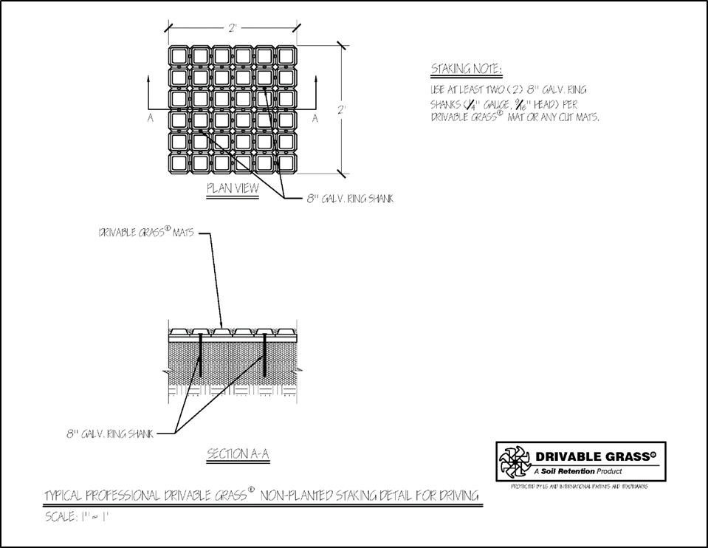

**Figure 3: Stake placement detail, Non-planted for Vehicular Driving**

* 1. Place the 8” Galvanized Stakes in two locations as shown on the installation detail. Using a hammer, set the 8” Galvanized Stakes in place in prior to using the air hammer.
  2. Place the ***Soil Retention Nail Guide*** over the 8” Galvanized Stake. Using the ***Soil Retention Hammer Rod*** and air hammer, drive the 8” Galvanized Stake to the base of the **Soil Retention Nail Guide**.

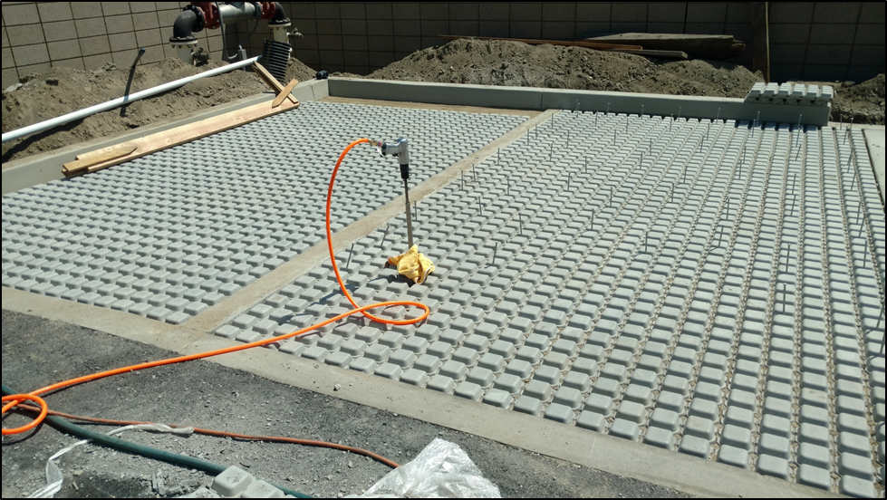

**Figure 4: Stakes set prior to using air hammer**.

Secure Drivable Grass® mats with 8” galvanized Stakes, driving the Stakes to the base of the “muffin top” into the soil underneath. **NOTE: DO NOT KEEP DRIVING THE STAKES AFTER THE END OF THE HAMMER ROD HAS REACHED THE BASE OF THE NAIL GUIDE AS THIS MAY CAUSE DAMAGE TO THE DRIVABLE GRASS® MATS.** The Stakes will hold the Drivable Grass® mats in place and prevent them from shifting over time.

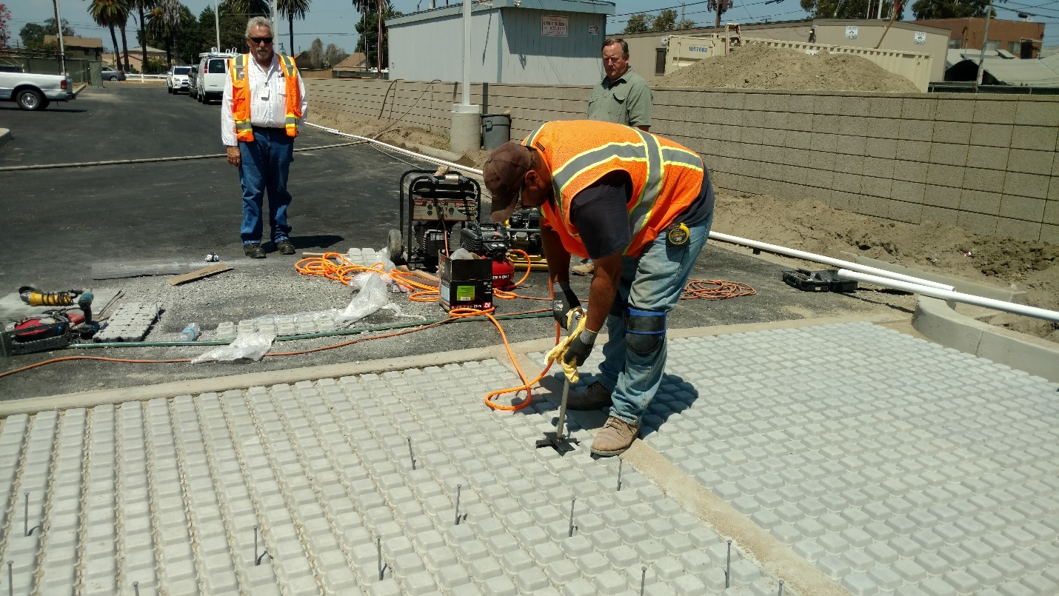

**Figure 5: Using Soil Retention Nail Guide** and **air hammer to drive Stakes.**

1. **Infill Installation**

* Crushed Angular Rock (3/8 minus)
* Decomposed Granite

(Estimated Infill Volume = 0.2 Cubic Feet per Mat OR 0.05 Cubic Feet per Square Foot)

1. Spread infill material uniformly across the Drivable Grass® mats with a push broom.
2. Leave the infill material approximately 1/4” below the Drivable Grass® mat surface.
3. Lightly water so that infill material could self-compact. Re-apply infill as necessary)

Artificial Turf: follow the weblink for video instruction <https://www.youtube.com/watch?v=biRe2Ry0dbs>